**Software needed to compile the St Croix Sales Force app:**

*Microsoft Visual Studio:* This is needed to organize and compile the files necessary for the app.

*Microsoft Access:* This is needed to work with existing databases containing customer data (**NOTE:** Access databases should be left in the .mbd format and **NOT** converted to the format .accda)

*Crystal Reports Basic For Visual Studio Package*

**To compile an exe. File from the Visual Studio Project**

Open the file *Kc01.vbproj* (a Microsoft Visual Studio **Project** file) that’s in the folder *SalesForce App*. This is the St Croix Sales Force App project.

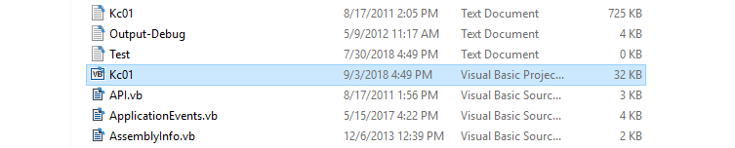

The project will open in the Visual Studio environment. The main window will be blank, and all of the files used in the app will be shown in the upper right window.

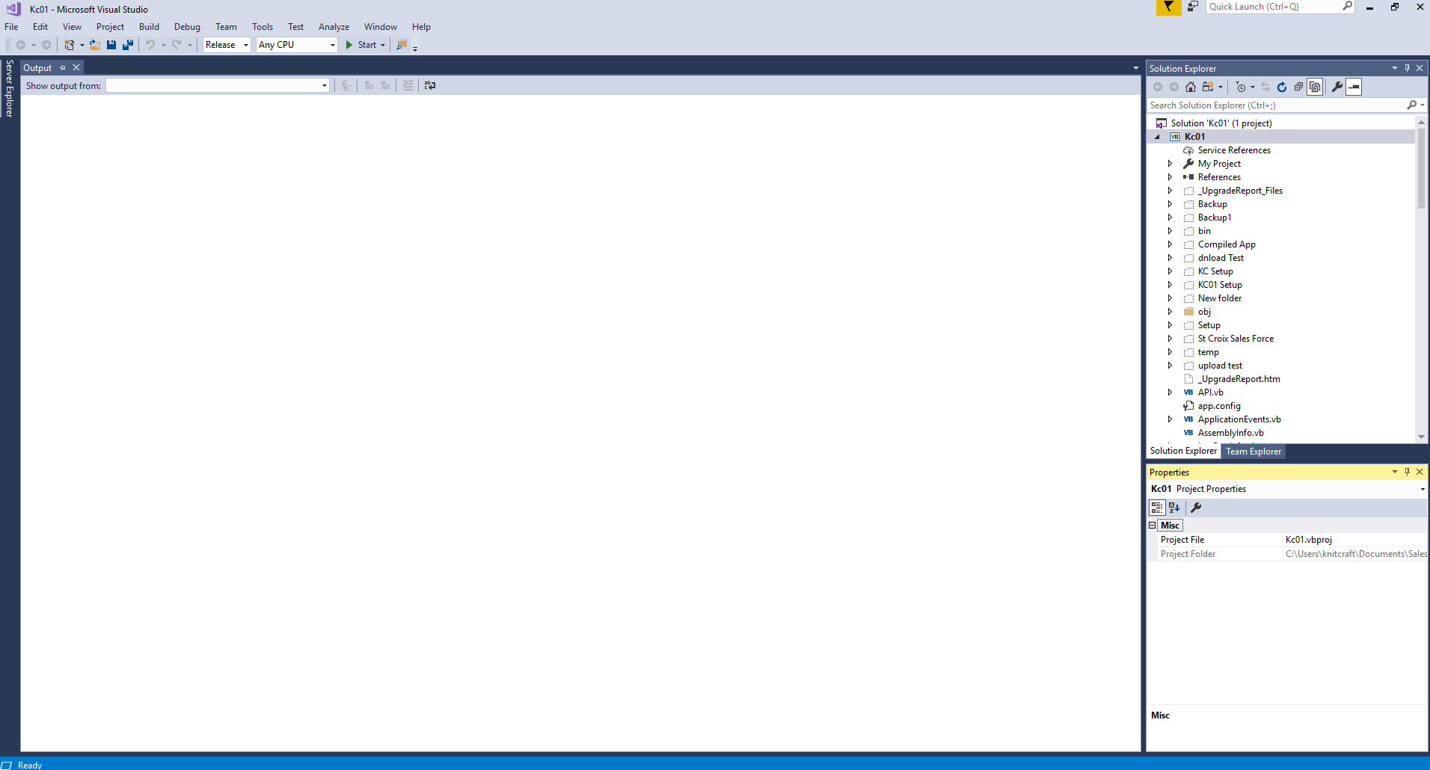

To compile the Visual Studio Project into an .exe file, select the following options in the toolbar:

*Release, Any CPU*. Then hit start.

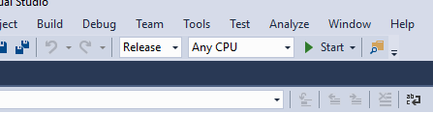

The app will compile and open the KC01.exe file.

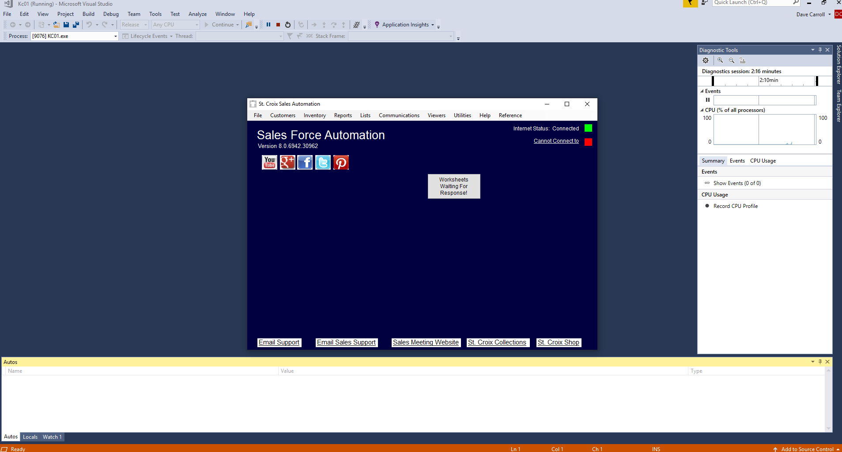

The KC01.exe file for the Sales Force Automation app is stored in the folder

*Documents - SalesForceApp - Compiled App - Release*

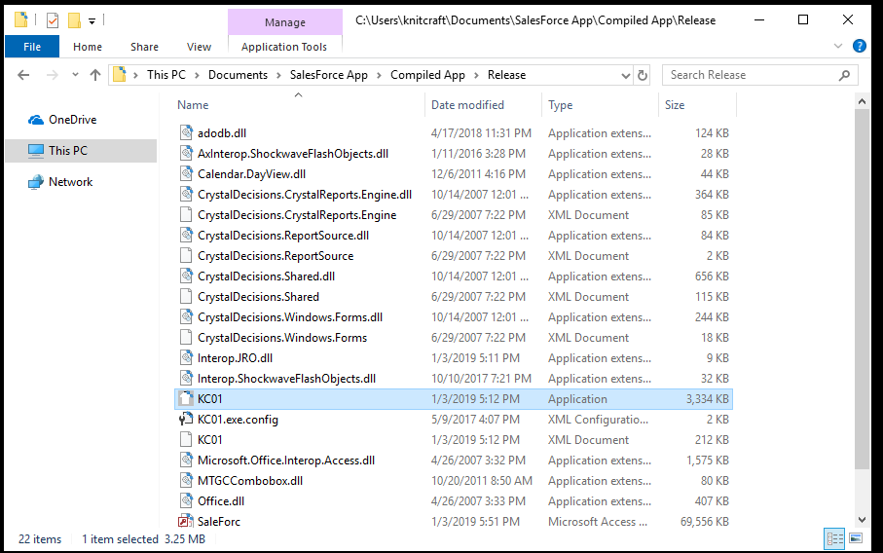

**Steps needed to install app on new machine**

In order to use the St Croix Sales Force app, environment variables that link to the customer database need to be created. To add these variables, go to *Edit the system and environment variables* under the Windows Control panel. From there, click the *Environment Variables* tab. From there, under *System Variables* hit *New* to add the two environment variables for the database. The first variable should be named *SalesforceDB* and the path should be set to ***\****DatabaseName*. For instance, if the microsoft access database used is named *saleforc.mbd*, the environment path should be set to *\saleforc.mbd*. The second environment variable should be named *SalesForceDBPath*, and the path should be set to the location of the database.